**Application**

Refer to the Air Quality data described previously, and the analyses we have done with Ozone as the response variable, and the five explanatory variables (including the two engineered features).

1. Find and **report the median value for wind speed and temperature**

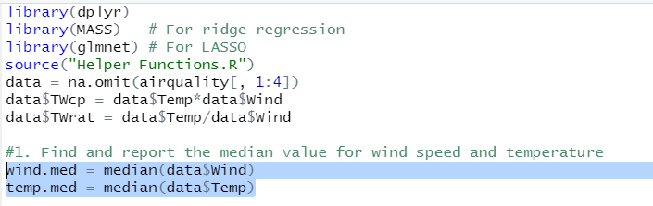

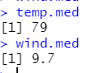

2. Use this median value to create high and low regions on both variables. Show values

for Temp, Wind, and the two high-low region factors for these variables.

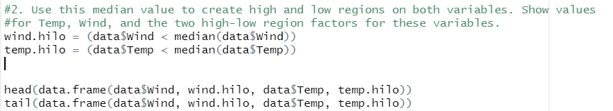

Wind Temp wind.split temp.split

1 7.4 67 FALSE FALSE

2 8.0 72 FALSE FALSE

3 12.6 74 TRUE FALSE

4 11.5 62 TRUE FALSE

5 8.6 65 FALSE FALSE

6 13.8 59 TRUE FALSE

7 20.1 61 TRUE FALSE

8 9.7 69 TRUE FALSE

9 9.2 66 FALSE FALSE

10 10.9 68 TRUE FALSE

11 13.2 58 TRUE FALSE

12 11.5 64 TRUE FALSE

13 12.0 66 TRUE FALSE

14 18.4 57 TRUE FALSE

15 11.5 68 TRUE FALSE

16 9.7 62 TRUE FALSE

17 9.7 59 TRUE FALSE

18 16.6 73 TRUE FALSE

19 9.7 61 TRUE FALSE

20 12.0 61 TRUE FALSE

21 12.0 67 TRUE FALSE

22 14.9 81 TRUE TRUE

23 5.7 79 FALSE TRUE

24 7.4 76 FALSE FALSE

25 9.7 82 TRUE TRUE

26 13.8 90 TRUE TRUE

27 11.5 87 TRUE TRUE

28 8.0 82 FALSE TRUE

29 14.9 77 TRUE FALSE

30 20.7 72 TRUE FALSE

31 9.2 65 FALSE FALSE

32 11.5 73 TRUE FALSE

33 10.3 76 TRUE FALSE

34 4.1 84 FALSE TRUE

35 9.2 85 FALSE TRUE

36 9.2 81 FALSE TRUE

37 4.6 83 FALSE TRUE

38 10.9 83 TRUE TRUE

39 5.1 88 FALSE TRUE

40 6.3 92 FALSE TRUE

41 5.7 92 FALSE TRUE

42 7.4 89 FALSE TRUE

43 14.3 73 TRUE FALSE

44 14.9 81 TRUE TRUE

45 14.3 80 TRUE TRUE

46 6.9 81 FALSE TRUE

47 10.3 82 TRUE TRUE

48 6.3 84 FALSE TRUE

49 5.1 87 FALSE TRUE

50 11.5 85 TRUE TRUE

51 6.9 74 FALSE FALSE

52 8.6 86 FALSE TRUE

53 8.0 85 FALSE TRUE

54 8.6 82 FALSE TRUE

55 12.0 86 TRUE TRUE

56 7.4 88 FALSE TRUE

57 7.4 86 FALSE TRUE

58 7.4 83 FALSE TRUE

59 9.2 81 FALSE TRUE

60 6.9 81 FALSE TRUE

61 13.8 81 TRUE TRUE

62 7.4 82 FALSE TRUE

63 4.0 89 FALSE TRUE

64 10.3 90 TRUE TRUE

65 8.0 90 FALSE TRUE

66 11.5 86 TRUE TRUE

67 11.5 82 TRUE TRUE

68 9.7 80 TRUE TRUE

69 10.3 77 TRUE FALSE

70 6.3 79 FALSE TRUE

71 7.4 76 FALSE FALSE

72 10.9 78 TRUE FALSE

73 10.3 78 TRUE FALSE

74 15.5 77 TRUE FALSE

75 14.3 72 TRUE FALSE

76 9.7 79 TRUE TRUE

77 3.4 81 FALSE TRUE

78 8.0 86 FALSE TRUE

79 9.7 97 TRUE TRUE

80 2.3 94 FALSE TRUE

81 6.3 96 FALSE TRUE

82 6.3 94 FALSE TRUE

83 6.9 91 FALSE TRUE

84 5.1 92 FALSE TRUE

85 2.8 93 FALSE TRUE

86 4.6 93 FALSE TRUE

87 7.4 87 FALSE TRUE

88 15.5 84 TRUE TRUE

89 10.9 80 TRUE TRUE

90 10.3 78 TRUE FALSE

91 10.9 75 TRUE FALSE

92 9.7 73 TRUE FALSE

93 14.9 81 TRUE TRUE

94 15.5 76 TRUE FALSE

95 6.3 77 FALSE FALSE

96 10.9 71 TRUE FALSE

97 11.5 71 TRUE FALSE

98 6.9 78 FALSE FALSE

99 13.8 67 TRUE FALSE

100 10.3 76 TRUE FALSE

101 10.3 68 TRUE FALSE

102 8.0 82 FALSE TRUE

103 12.6 64 TRUE FALSE

104 9.2 71 FALSE FALSE

105 10.3 81 TRUE TRUE

106 10.3 69 TRUE FALSE

107 16.6 63 TRUE FALSE

108 6.9 70 FALSE FALSE

109 14.3 75 TRUE FALSE

110 8.0 76 FALSE FALSE

111 11.5 68 TRUE FALSE

1. Fit a linear regression with the two region variables.
2. **Report the results from summary().**

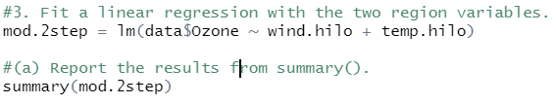

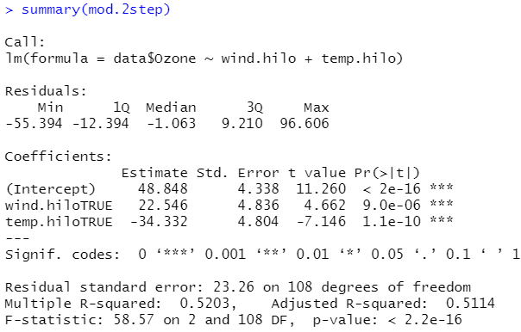

(b) Do the two variables have statistically significant influence on the mean ozone level

at the 5% Type 1 error rate? **Report their p-values and your conclusion.**

**(No hypotheses needed.)**

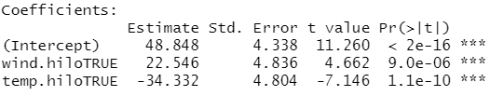

-> Both p-values < 0.05, so both are statistically significant

(c) Make a 3-D plot of the surface. **Report a screenshot from some angle that**

**shows the whole surface and describe how the surface changes with**

1. **each variable (use one short sentence each).**

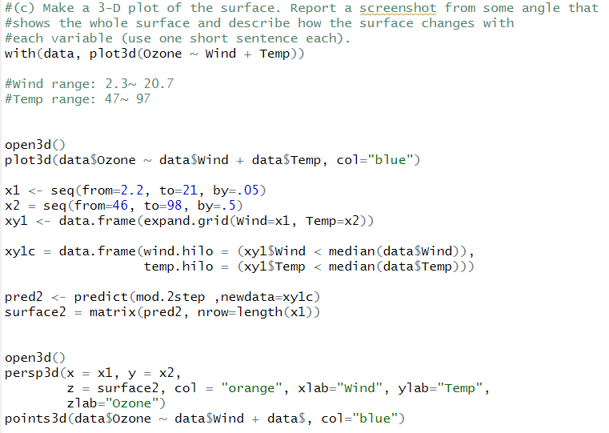

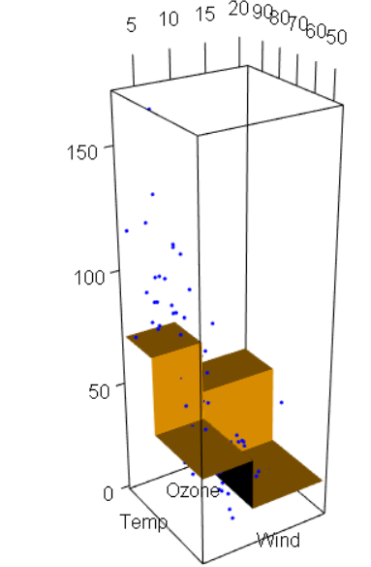

It looks like when Wind get larger, Ozone will get smaller.

It looks like Temp get larger, Ozone will also get larger

4. Add the interaction of the two region variables to the model

(a) **Report the results from summary().**

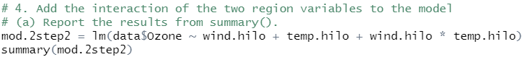

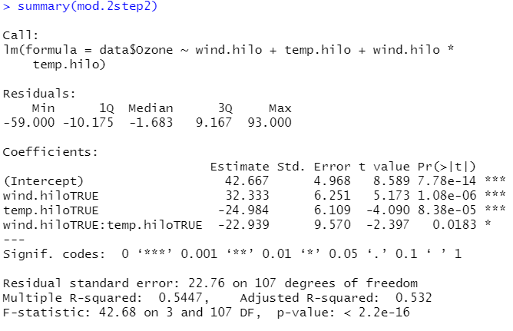

(b) Does the interaction have statistically significant influence on the mean ozone level

at the 5% Type 1 error rate? **Report the p-values and your conclusion. (No**

**hypotheses needed.)**



**->** Yes, because all of the values are below 0.05

(c) Make a 3-D plot of the surface. **Report a screenshot from some angle that**

**shows the whole surface and describe how the interaction affects the**

**surface (use one sentence).**

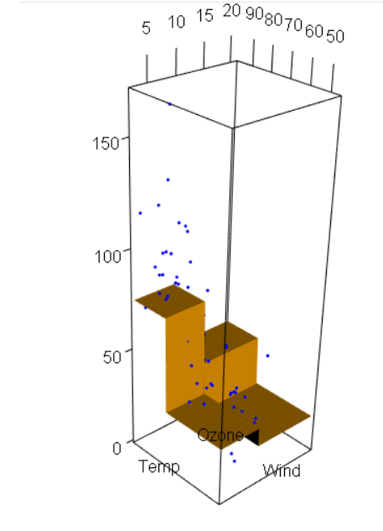

Couldn’t find that much difference.